**一、展示權值矩陣 W1 與 W2 之初始值、訓練變化、最終值**

initialize W1: [[-0.32344333 0.95318594][ 0.42953142 0.04554452]]

initialize W2: [[-0.99459151 0.28564619][ 0.23852008 -1.9424014]]

final W1: [[-7.26064143 7.51015781][-7.0499215 6.74125435]]

final W2: [[-7.26064143 7.51015781][-7.0499215 6.74125435]]

訓練變化：

W1: [[-0.32350346 0.95314663] [ 0.42900835 0.04511581]]

W2: [[-0.32350346 0.95314663] [ 0.42900835 0.04511581]]

W1: [[-0.35315989 0.98963714] [ 0.282622 0.09711236]]

W2: [[-0.35315989 0.98963714] [ 0.282622 0.09711236]]

W1: [[-0.42553045 1.06160455] [ 0.21244504 0.17067605]]

W2: [[-0.42553045 1.06160455] [ 0.21244504 0.17067605]]

W1: [[-0.55774084 1.19187385] [ 0.16241042 0.24207431]]

W2: [[-0.55774084 1.19187385] [ 0.16241042 0.24207431]]

W1: [[-0.68635132 1.3208844 ] [ 0.13929123 0.29180403]]

W2: [[-0.68635132 1.3208844 ] [ 0.13929123 0.29180403]]

W1: [[-0.88557726 1.52080517] [ 0.11981572 0.35744587]]

W2: [[-0.88557726 1.52080517] [ 0.11981572 0.35744587]]

W1: [[-1.20126904 1.83249069] [ 0.10237452 0.45441817]]

W2: [[-1.20126904 1.83249069] [ 0.10237452 0.45441817]]

W1: [[-1.55841828 2.17975595] [ 0.08657278 0.56661926]]

W2: [[-1.55841828 2.17975595] [ 0.08657278 0.56661926]]

W1: [[-1.99599328 2.60697436] [ 0.06213501 0.71726726]]

W2: [[-1.99599328 2.60697436] [ 0.06213501 0.71726726]]

W1: [[-2.97495047 3.59904059] [-0.08924161 1.12167962]]

W2: [[-2.97495047 3.59904059] [-0.08924161 1.12167962]]

W1: [[-3.51064088 4.1498537 ] [-0.4288582 1.32337367]]

W2: [[-3.51064088 4.1498537 ] [-0.4288582 1.32337367]]

W1: [[-4.43488828 4.94816151] [-2.37804503 2.20786365]]

W2: [[-4.43488828 4.94816151] [-2.37804503 2.20786365]]

W1: [[-4.8319147 5.252825 ] [-3.26810892 3.0039793 ]]

W2: [[-4.8319147 5.252825 ][-3.26810892 3.0039793 ]]

W1: [[-5.04542216 5.41906248] [-3.70524374 3.42020938]]

W2: [[-5.04542216 5.41906248] [-3.70524374 3.42020938]]

W1: [[-5.37202644 5.68449807] [-4.31881254 4.01731447]]

W2: [[-5.37202644 5.68449807] [-4.31881254 4.01731447]]

W1: [[-5.50695896 5.79931703] [-4.55492152 4.24955203]]

W2: [[-5.50695896 5.79931703] [-4.55492152 4.24955203]]

W1: [[-5.69449828 5.96437057] [-4.8684583 4.55939013]]

W2: [[-5.69449828 5.96437057] [-4.8684583 4.55939013]]

W1: [[-5.8253247 6.08321205] [-5.07813049 4.76735909]]

W2: [[-5.8253247 6.08321205] [-5.07813049 4.76735909]]

W1: [[-5.97680976 6.22435713] [-5.31261072 5.00057716]]

W2: [[-5.97680976 6.22435713] [-5.31261072 5.00057716]]

W1: [[-6.07051974 6.31340236] [-5.45358911 5.14109658]]

W2: [[-6.07051974 6.31340236] [-5.45358911 5.14109658]]

W1: [[-6.13862845 6.37887267] [-5.55424238 5.24154996]]

W2: [[-6.13862845 6.37887267] [-5.55424238 5.24154996]]

W1: [[-6.20069676 6.43904394] [-5.64471252 5.33192579]]

W2: [[-6.20069676 6.43904394] [-5.64471252 5.33192579]]

W1: [[-6.26461281 6.5014735 ] [-5.73668203 5.42387714]]

W2: [[-6.26461281 6.5014735 ] [-5.73668203 5.42387714]]

W1: [[-6.31726995 6.55323498] [-5.81158025 5.49881463]]

W2: [[-6.31726995 6.55323498] [-5.81158025 5.49881463]]

W1: [[-6.45493288 6.68979991] [-6.00389937 5.69143216]]

W2: [[-6.45493288 6.68979991] [-6.00389937 5.69143216]]

W1: [[-6.51345791 6.74833684] [-6.08422409 5.77195442]]

W2: [[-6.51345791 6.74833684] [-6.08422409 5.77195442]]

W1: [[-6.55476274 6.78980035] [-6.14042871 5.82831879]]

W2: [[-6.55476274 6.78980035] [-6.14042871 5.82831879]]

W1: [[-6.60548101 6.84086893] [-6.20891345 5.89701916]]

W2: [[-6.60548101 6.84086893] [-6.20891345 5.89701916]]

W1: [[-6.68444974 6.9206897 ] [-6.31443327 6.00290893]]

W2: [[-6.68444974 6.9206897 ] [-6.31443327 6.00290893]]

W1: [[-6.73588833 6.97286156] [-6.38247161 6.07120497]]

W2: [[-6.73588833 6.97286156] [-6.38247161 6.07120497]]

W1: [[-6.77157188 7.00912738] [-6.42936188 6.11827944]]

W2: [[-6.77157188 7.00912738] [-6.42936188 6.11827944]]

W1: [[-6.80246164 7.04056588] [-6.46975467 6.15883424]]

W2: [[-6.80246164 7.04056588] [-6.46975467 6.15883424]]

W1: [[-6.82365155 7.06215468] [-6.49735955 6.18655122]]

W2: [[-6.82365155 7.06215468] [-6.49735955 6.18655122]]

W1: [[-6.85743922 7.09661378] [-6.54120476 6.23057616]]

W2: [[-6.85743922 7.09661378] [-6.54120476 6.23057616]]

W1: [[-6.89692295 7.13693329] [-6.59218122 6.28176312]]

W2: [[-6.89692295 7.13693329] [-6.59218122 6.28176312]]

W1: [[-6.96788876 7.20952451] [-6.68312332 6.37308073]]

W2: [[-6.96788876 7.20952451] [-6.68312332 6.37308073]]

W1: [[-7.01538978 7.25819065] [-6.74352634 6.43372998]]

W2: [[-7.01538978 7.25819065] [-6.74352634 6.43372998]]

W1: [[-7.04412671 7.28765867] [-6.77989267 6.47024224]]

W2: [[-7.04412671 7.28765867] [-6.77989267 6.47024224]]

W1: [[-7.08794108 7.33262155] [-6.83509157 6.52565812]]

W2: [[-7.08794108 7.33262155] [-6.83509157 6.52565812]]

W1: [[-7.10998491 7.35525725] [-6.86275264 6.55342544]]

W2: [[-7.10998491 7.35525725] [-6.86275264 6.55342544]]

W1: [[-7.14769584 7.39400023] [-6.90990594 6.60075539]]

W2: [[-7.14769584 7.39400023] [-6.90990594 6.60075539]]

W1: [[-7.16449778 7.41126926] [-6.9308482 6.62177409]]

W2: [[-7.16449778 7.41126926] [-6.9308482 6.62177409]]

W1: [[-7.19296341 7.44053552] [-6.96623639 6.65728837]]

W2: [[-7.19296341 7.44053552] [-6.96623639 6.65728837]]

W1: [[-7.22151622 7.46990211] [-7.00161891 6.69279277]]

W2: [[-7.22151622 7.46990211] [-7.00161891 6.69279277]]

W1: [[-7.24871692 7.49788702] [-7.03522183 6.72650724]]

W2: [[-7.24871692 7.49788702] [-7.03522183 6.72650724]]

W2: [[-7.26060802 7.51012343] [-7.04988035 6.74121307]]

W1: [[-7.26061637 7.51013203] [-7.04989064 6.74122339]]

W1: [[-7.26064143 7.51015781] [-7.0499215 6.74125435]]

W2: [[-7.26064143 7.51015781] [-7.0499215 6.74125435]]

二、**繪出上題中權值矩陣 W1 所對應的切割直線**

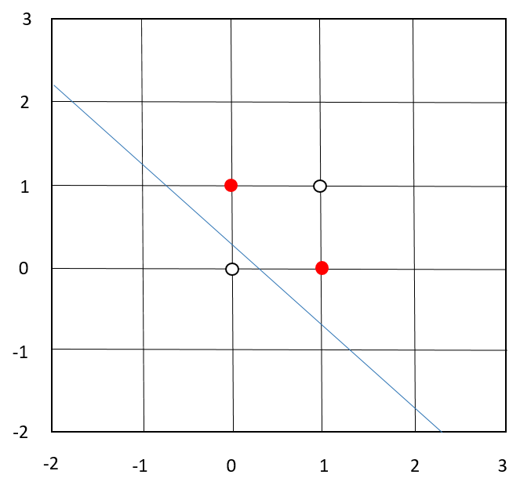

三、**列出 MSE 的相對變化**

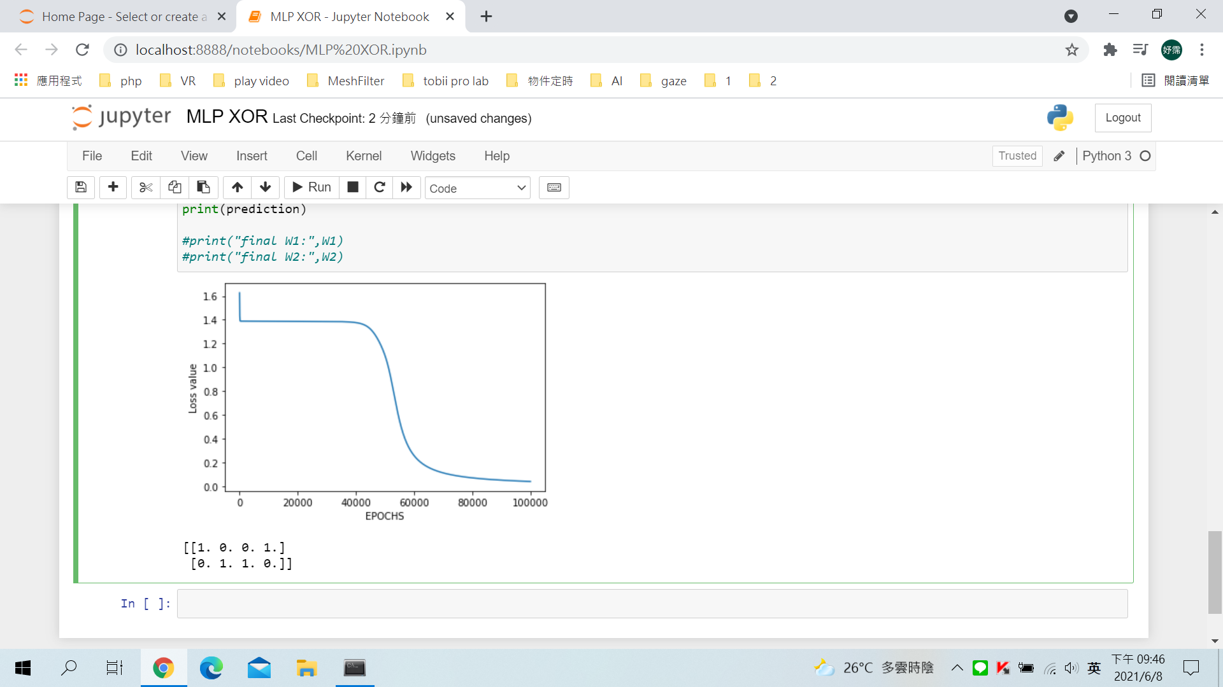

**四、變化過程如何呈現以及用幾個階段呈現，請各別發揮**

**(1)**定義Sigmoid 函數

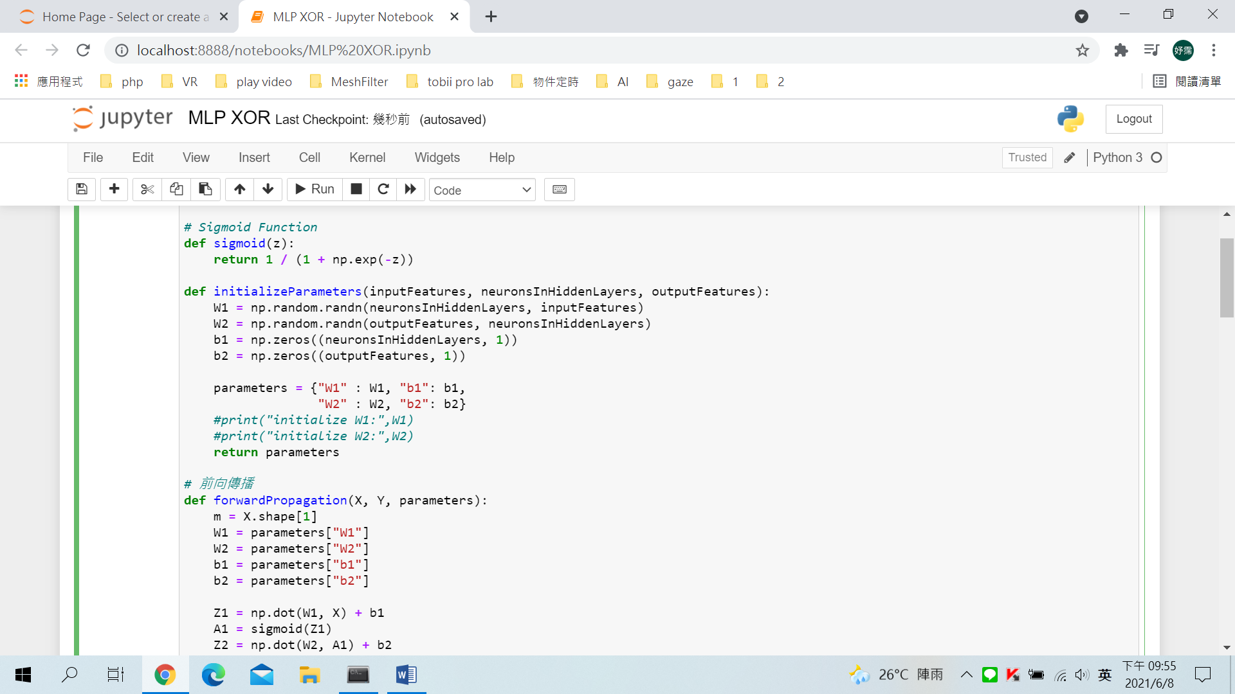

**(2)**初始化神經網絡參數（權重、偏差）並定義模型超參數（迭代次數、學習率）



**(3)**前向傳播

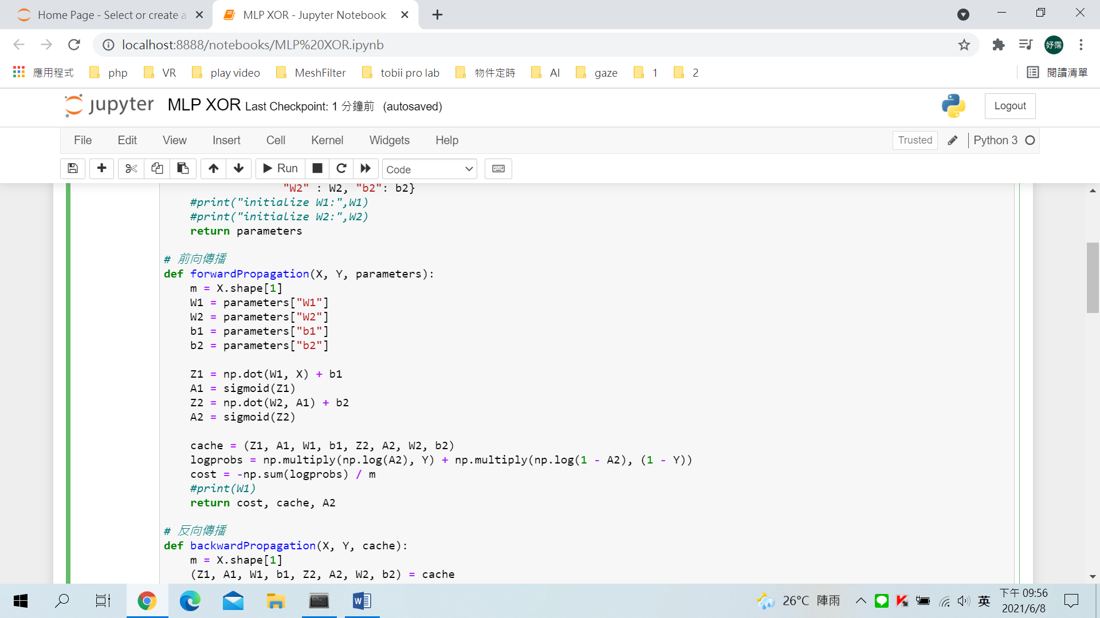

**(4)**反向傳播

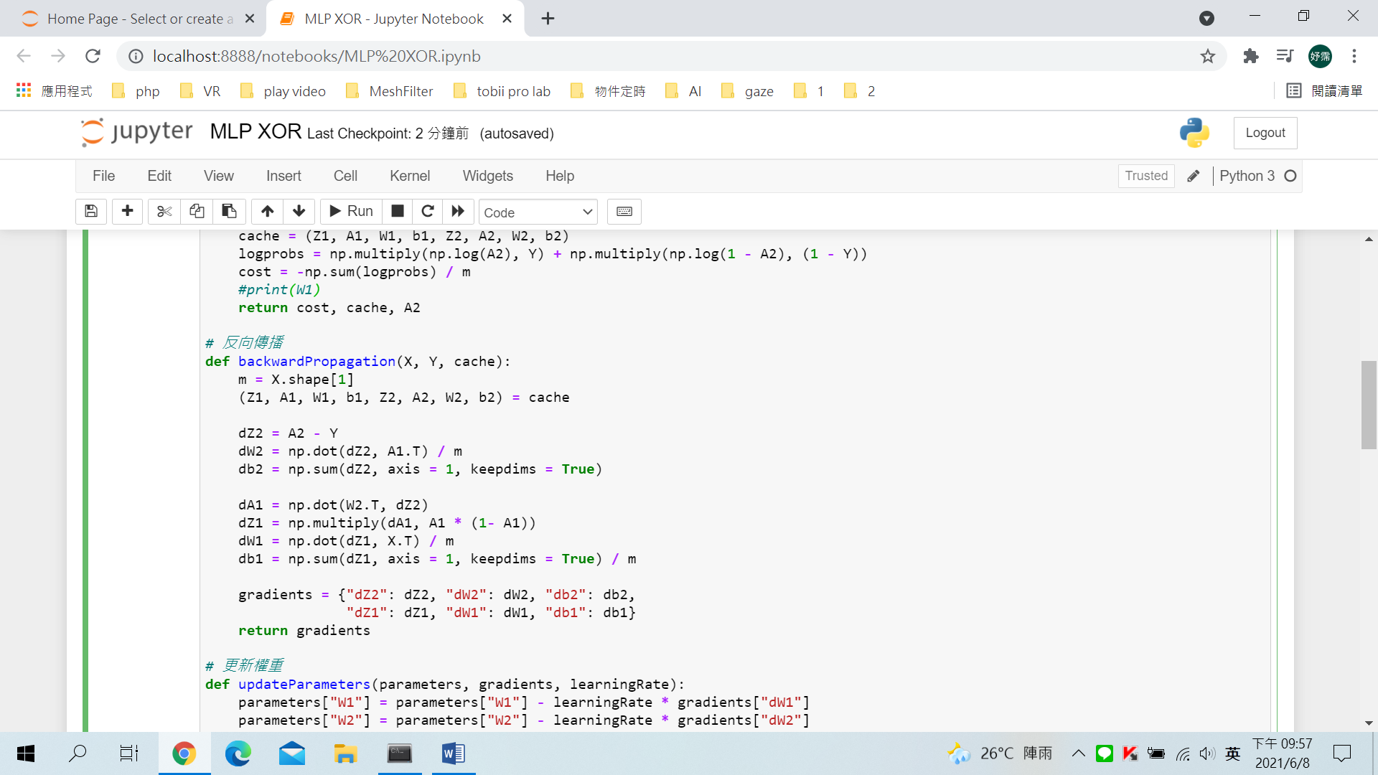

**(5)**更新權重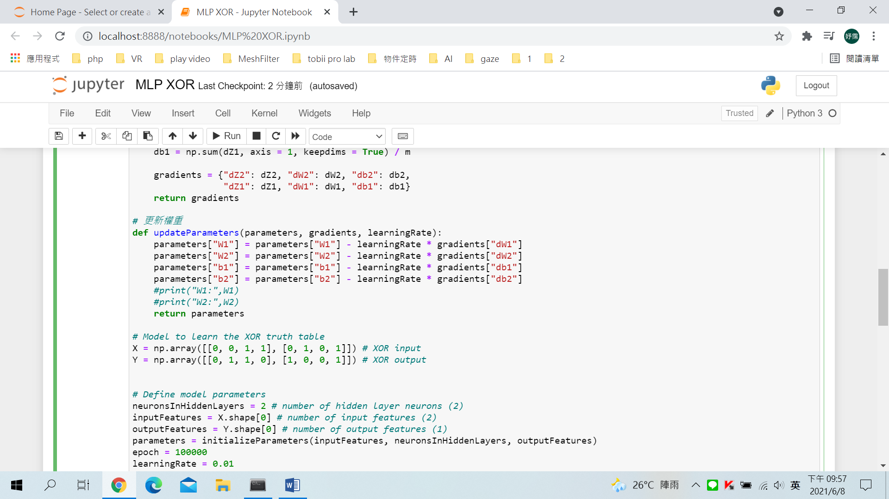

**(6)**訓練學習模型

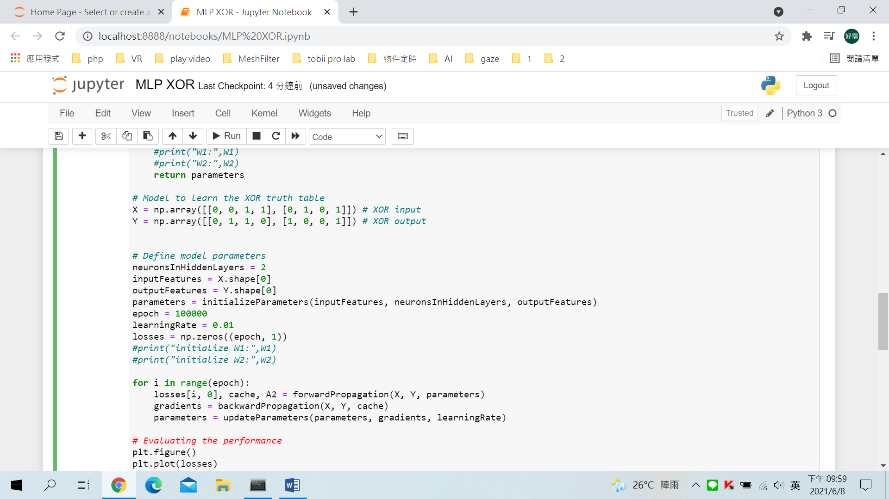

**(7)**繪製MSE

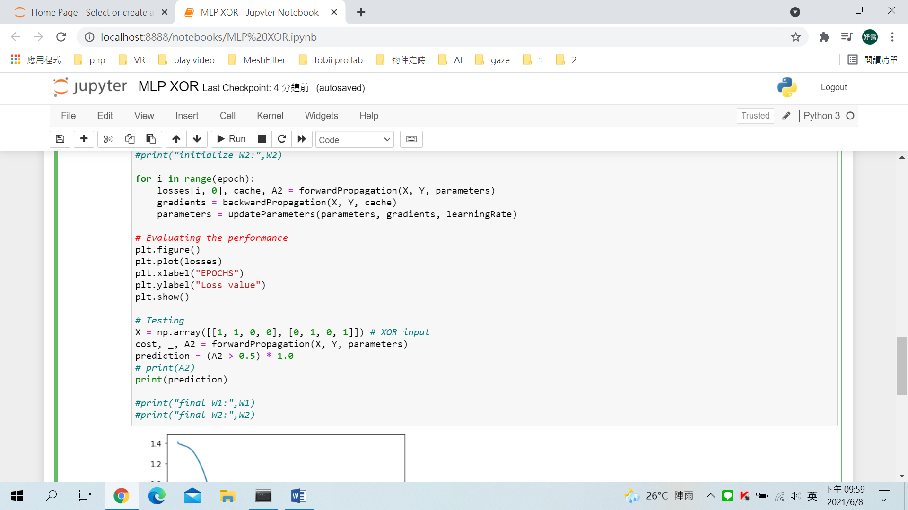

**(8)**測試模型性能

